Thermal Mangement system of a drone pod system

Charlie Nitschelm
Thermal System

INTRODUCTION
The Reaper fitted with a Seaspray 7500E Drone Pod needs an efficient thermal management system to maintain a temperature of 20 °C during its entire flight. The pod will experience outside environments as cold as -20 °C during the peak of its flight, and 50 °C during takeoff. Specifically, given these conditions, what is the best-known refrigerant to use in the drone pods thermal management system that is most efficient for the conditionals it will experience, its environmental impact, safety handling and cost considerations.
Refrigerant selection
To narrow down the selection of the desired refrigerant to three top choices, a performance analysis needs to happen on several widely used refrigerants. Once an array of refrigerants are selected for their particular performance in the Seaspray Drone Pod, other considerations can be made regarding to its environmental impact, safety handling and overall cost to determine the most desired refrigerant for the drone pod thermal management system.
Performance analysis
MATLAB and CoolProps is utilized to numerically calculate the coefficient of performance (COP) of any refrigerant that could be used as the working fluid of the drone pod thermal management system. The figure below details the differences in COP of various types of refrigerants used today. All detailed graphs are within the appendix.

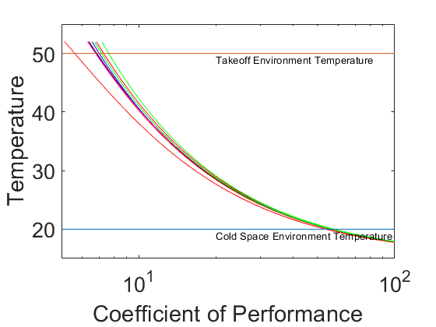
Figure 1 - Coefficient of Performance of Several Refrigerants
The graph tests five different types of refrigerants: R-Refrigerants like R410a, water and heavy water, isobutane and isobutene, MDM and cyclohexane, and lastly acetone and ammonia. The top four refrigerants with the highest COP with respect to the thermal management system of the drone pod at takeoff are acetone with a COP of 7.88, R123 with a COP of 7.55, ammonia with a COP of 7.40, and lastly R290 with a COP of 6.87.
environment, safety, cost & flow rate
Very low to zero environmental harm, safe when the refrigerant is handled and the cost per kilogram of the refrigerant are all-important factors in choosing the desired propellant. The majority of acetone is released into the atmosphere by industrial purposes. It is flammable at room temperature and is a risk to the oxygen depletion in aquatic systems due to microbial consumption [1]. R123, the second most efficient refrigerant analyzed, has little to zero effect on the environment but can be toxic to people when applied to the body by accident [2]. Ammonia is the third most efficient refrigerant for the system, and has huge risks to the environment and people [3]. R290 is the fourth most efficient refrigerant, and has little to zero impact on the environment and is non-toxic to people when handling [4]. The required mass flow rate of the working fluid is also important to the final desired refrigerant. The figure below shows that amount of mass flow rate the thermal management system requires for a given outside temperature and refrigerant
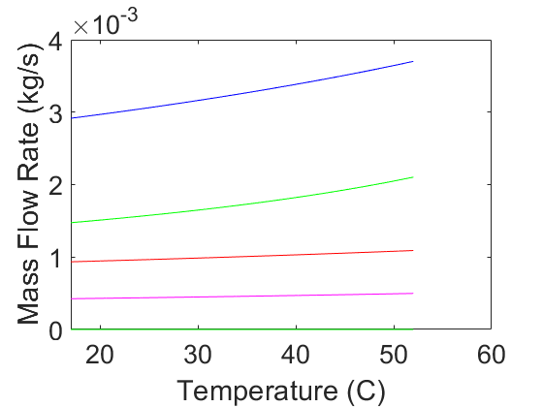
Figure 2 - Mass Flow Rate of the Most Efficient Refrigerants

The monetary cost of the working fluid must also be reasonable. Acetone, R123, ammonia and R290 has a price per kilogram of $20.00, $3.00, $8.00 and $7.00, respectively [4] [5] [6]. All of the prices are in reasonable range for the Department of Defense. This information on environmental impact, safety handling, cost and mass flow rate yields a desired refrigerant for the thermal management system of the drone pod. Acetone, although the most efficient and second least mass flow rate, is too dangerous regarding its environmental impact and safety. R123, the second most efficient refrigerant and highest mass flow rate, has nearly zero impact to the environment but can be toxic to people when handling. The third most efficient refrigerant, ammonia, is efficient and requires the least mass flow rate, but has huge risk to the environment and people. With the considerations of efficiency, mass flow rate, environmental impact, safety handling and cost, R290 is clearly the most desired refrigerant for the system.
Various environmental temperatures
R290, the fourth most efficient refrigerant and third least required mass flow rate, is non-toxic to people, thermally stable, and has little to zero effect on the environment. Now that the desired refrigerant, R290, is chosen, a more in depth look of the cycle can be brought forward. Below are the T-s, P-h and P-v diagrams of the R290 refrigeration cycle with the expected takeoff and apogee outside temperatures.
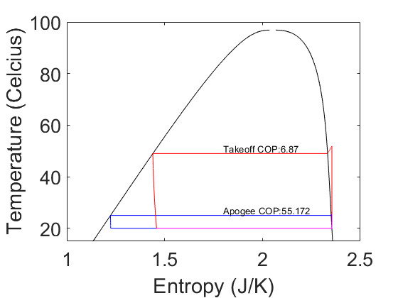
Figure 3 - T-s Refrigeration Cycle of R290
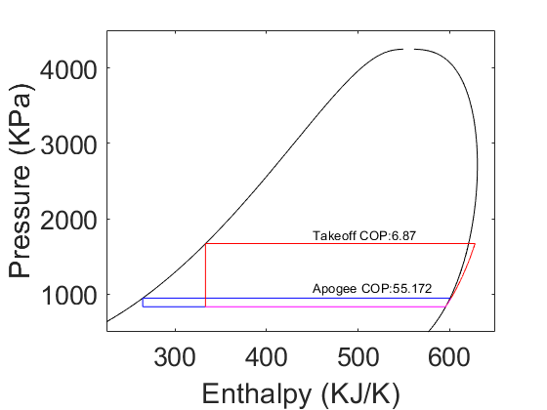
Figure 4 - P-h Refrigeration Cycle of R290
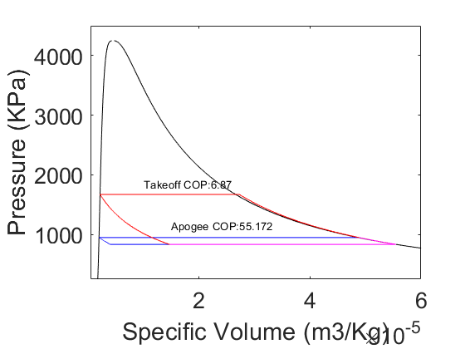
Figure 5 - P-v Refrigeration Cycle of R290

As the Drone Pod is taking off, it can encounter an outside temperature of almost 50 degrees Celsius. With that huge difference in outside temperature to a desired temperature of 20 degrees Celsius, a COP is calculated to be 6.67. However, when the Drone Pod rises to an altitude that causes the outside temperature to fall below the desired temperature inside the Drone Pod, the Drone Pod is assumed to be perfectly insulated. This then creates the outside temperature to just be the change in temperature for the condenser, which was selected to be 5 Kelvin. That COP is much higher at 55 because of the small temperature variation of the entire refrigeration cycle. If the Drone Pod was considered not perfectly insulated, a thermal management system must be designed to switch to a heat pump when the outside temperature falls below the desired internal temperature of the pod.

final recommendation
This report investigated the effect of different refrigerants applied to a thermal management system of the Seaspray Drone Pod with respect to its calculated COP. The best refrigerants for the system could then be investigated further for its environmental impact, safety handling and cost. The refrigerant is desired to have little to zero impact to the environment, poses little risk to overall handling, and minimal material cost. R290, the fourth most efficient refrigerant analyzed, was then selected as the desired refrigerant for the system as it is very efficient comparatively, low mass flow rate, safe to the environment, poses little to no threat to people, and has a very low material cost. If the requirements and preferences of the selected refrigerant changes, then another analysis could be required to determine the best refrigerant for the given conditions.

References
[1] “Risks and Benefits.” Acetone,badacetone.weebly.com/risks-and-benefits.html.
[2] Refrigerants, National. “R123 Safety Data Sheet.” SDS, www.refrigerants.com/pdf/SDS%20R123.pdf.
[3] “R290 (CARE 40) Propane.” Linde Gas, www.linde-gas.com/en/products_and_supply/refrigerants/natural_refrigerants/r290_propane/index.html.
[4] “Acetone | Price | per Kg | USD.” PharmaCompass.com, www.pharmacompass.com/price/acetone.
[5] “Buy Chemicals 99.9% Purity Cyclohexane 110-82-7 - Buy Cyclohexane,Cyclohexane Price,Cas:110-82-7 Product on Alibaba.com.” Www.alibaba.com, www.alibaba.com/product-detail/buy-chemicals-99-9-purity-Cyclohexane_60579895295.html?spm=a2700.7724838.2017115.51.4424711fe06nk3.
[6] “Refrigerant Gas Cyclohexane R134a - Buy Refrigerant Hfc 134a Good,Hfc R134a Refrigerant,Hfc 134a Refrigerant Product on Alibaba.com.”Www.alibaba.com, www.alibaba.com/product-detail/refrigerant-gas-cyclohexane-R134a_1384971567.html.

Appendix

Detailed Figures

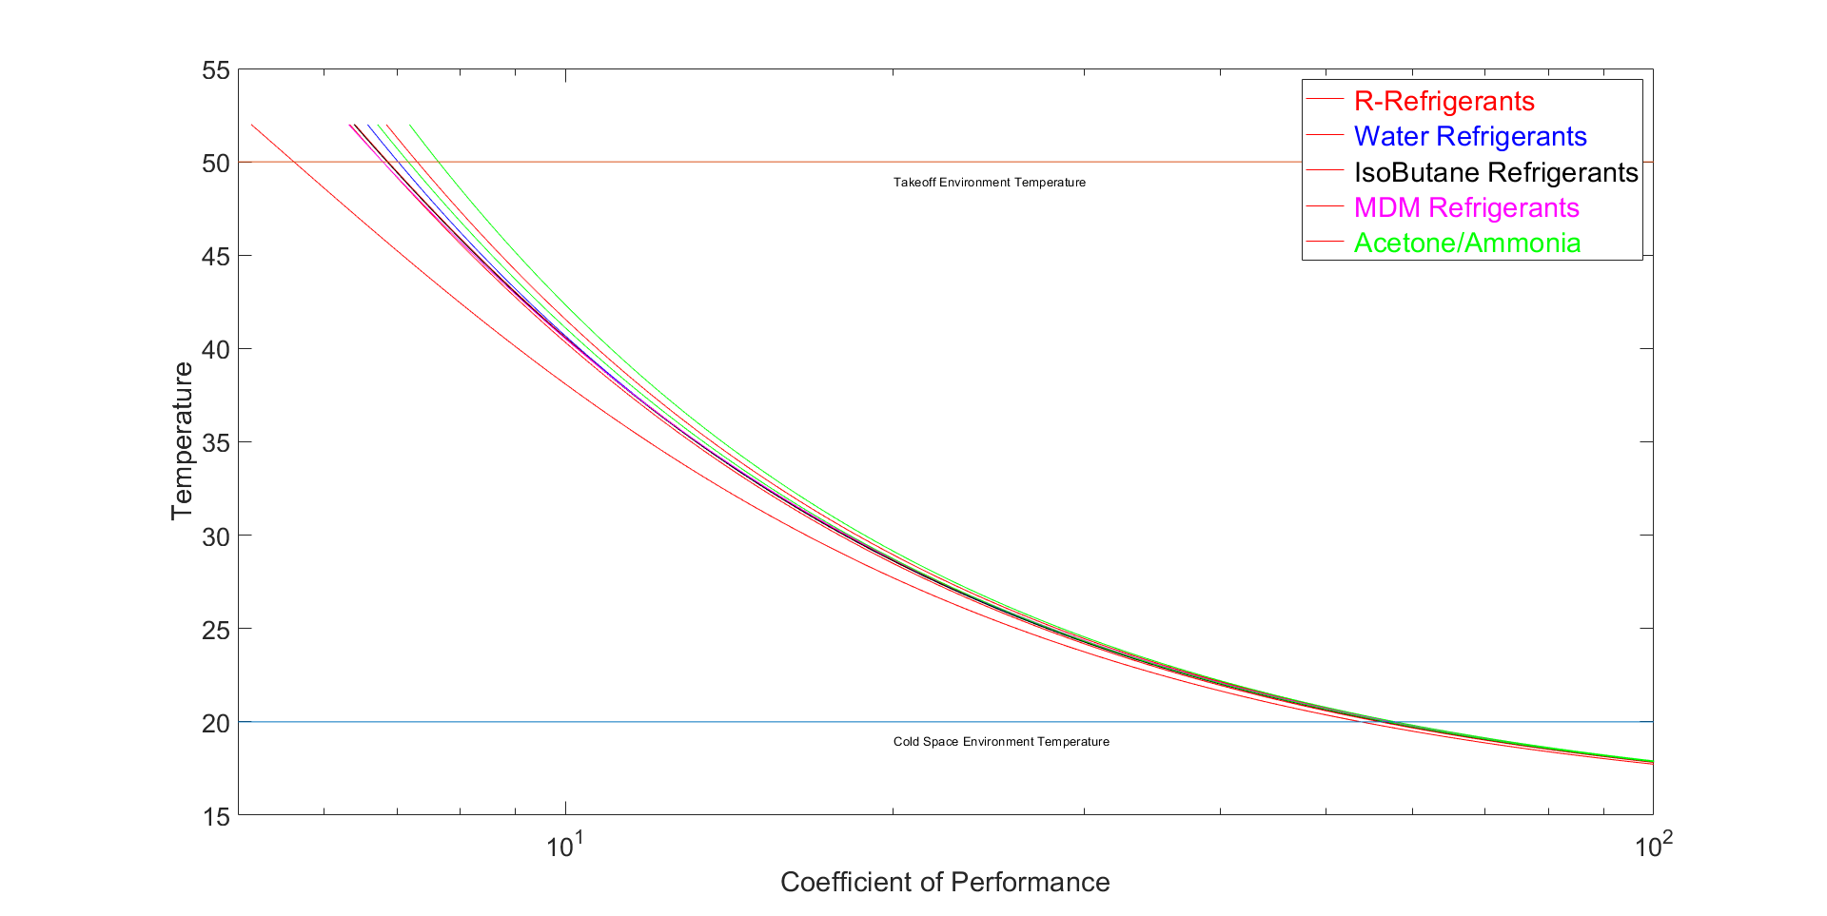
Figure 6 - Coefficient of Performance of Several Refrigerants

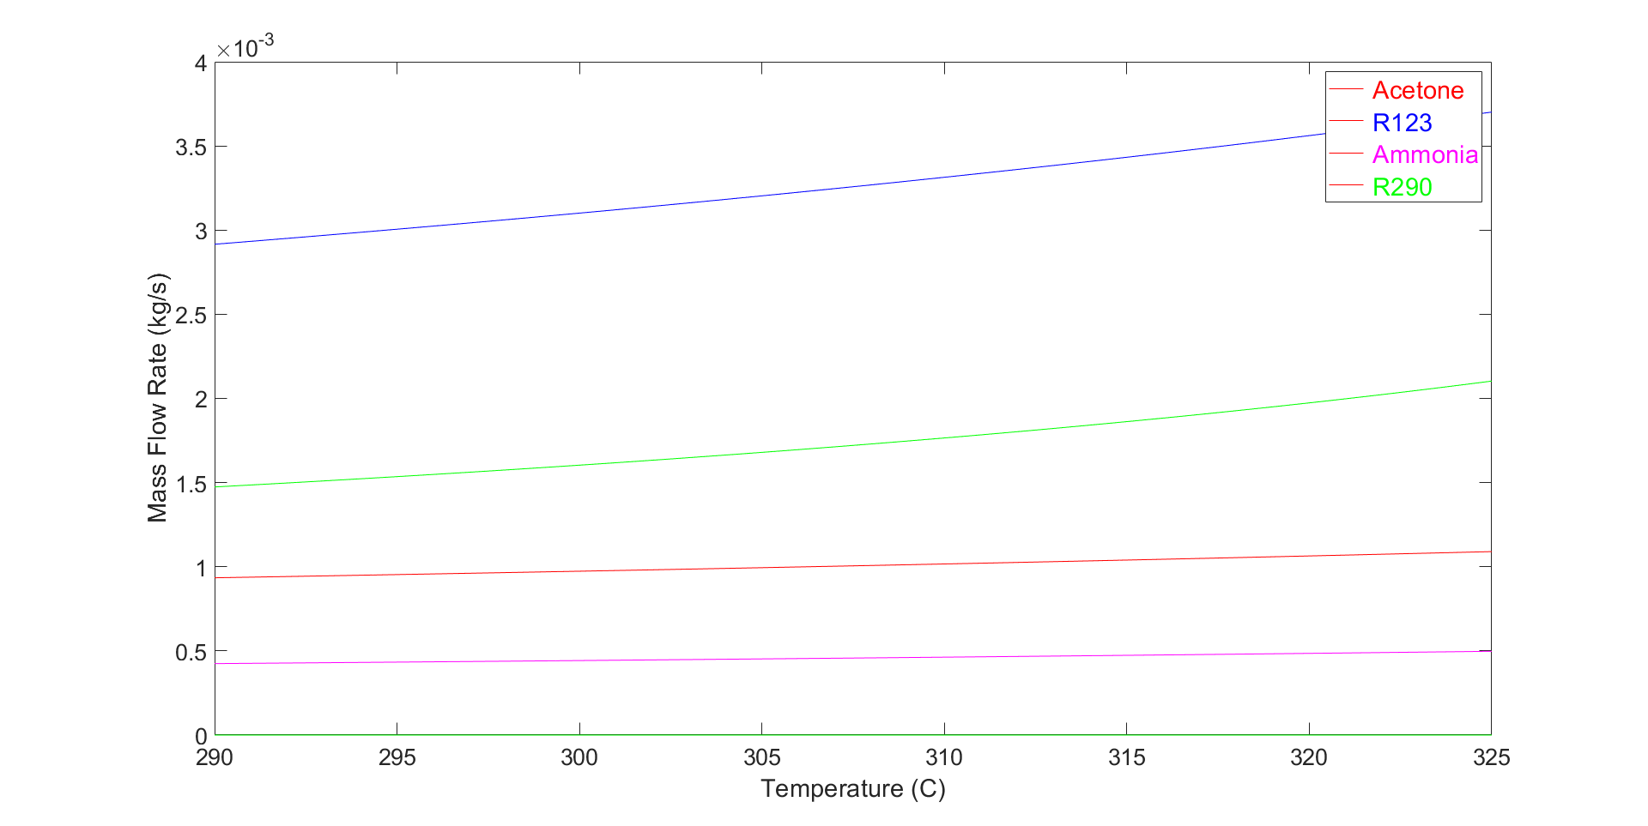
Figure 7 - Mass Flow Rate of Most Efficient Refrigerants
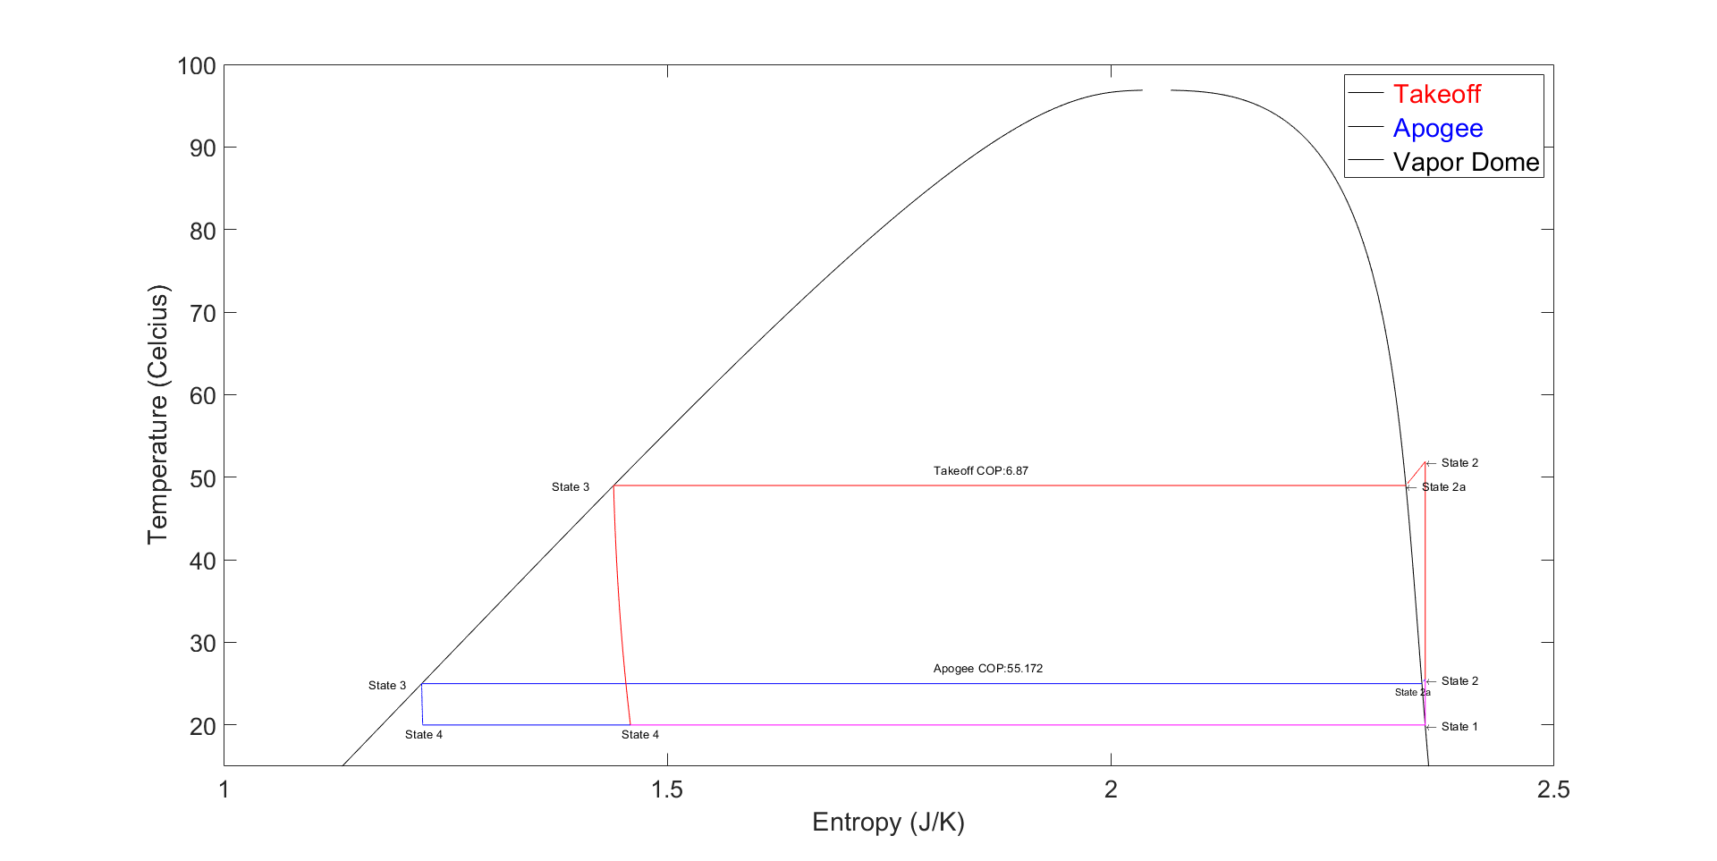
Figure 8 - T-s Refrigeration Cycle of R290
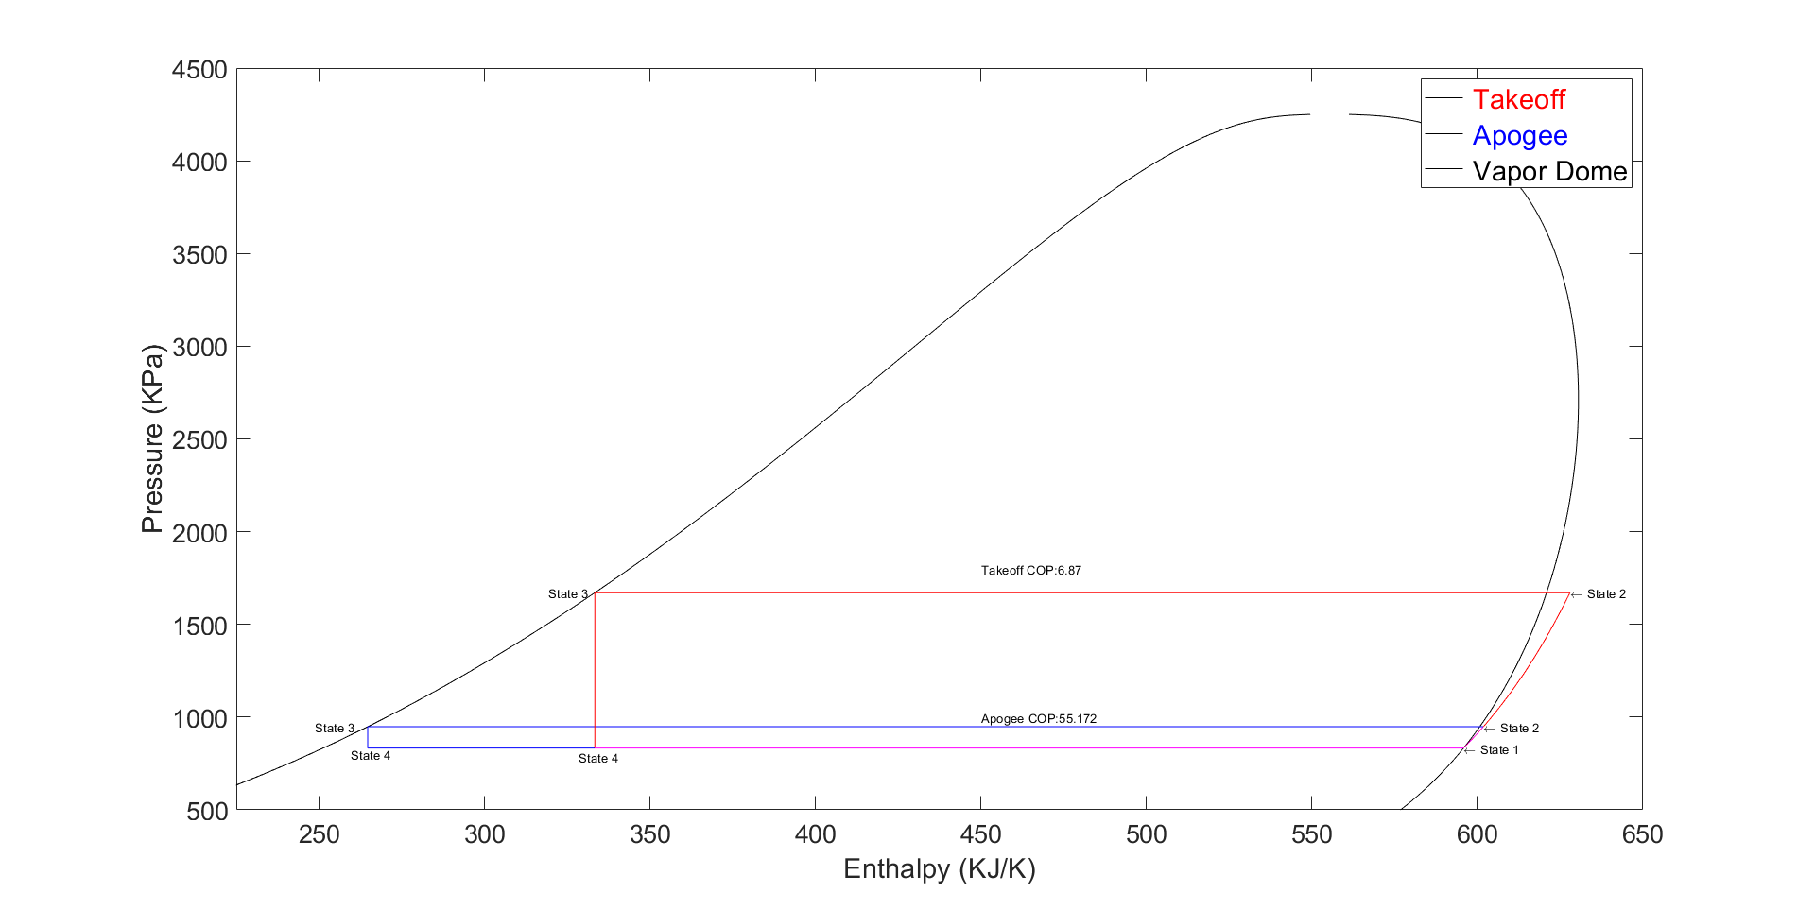
Figure 9 - P-h Refrigeration Cycle of R290
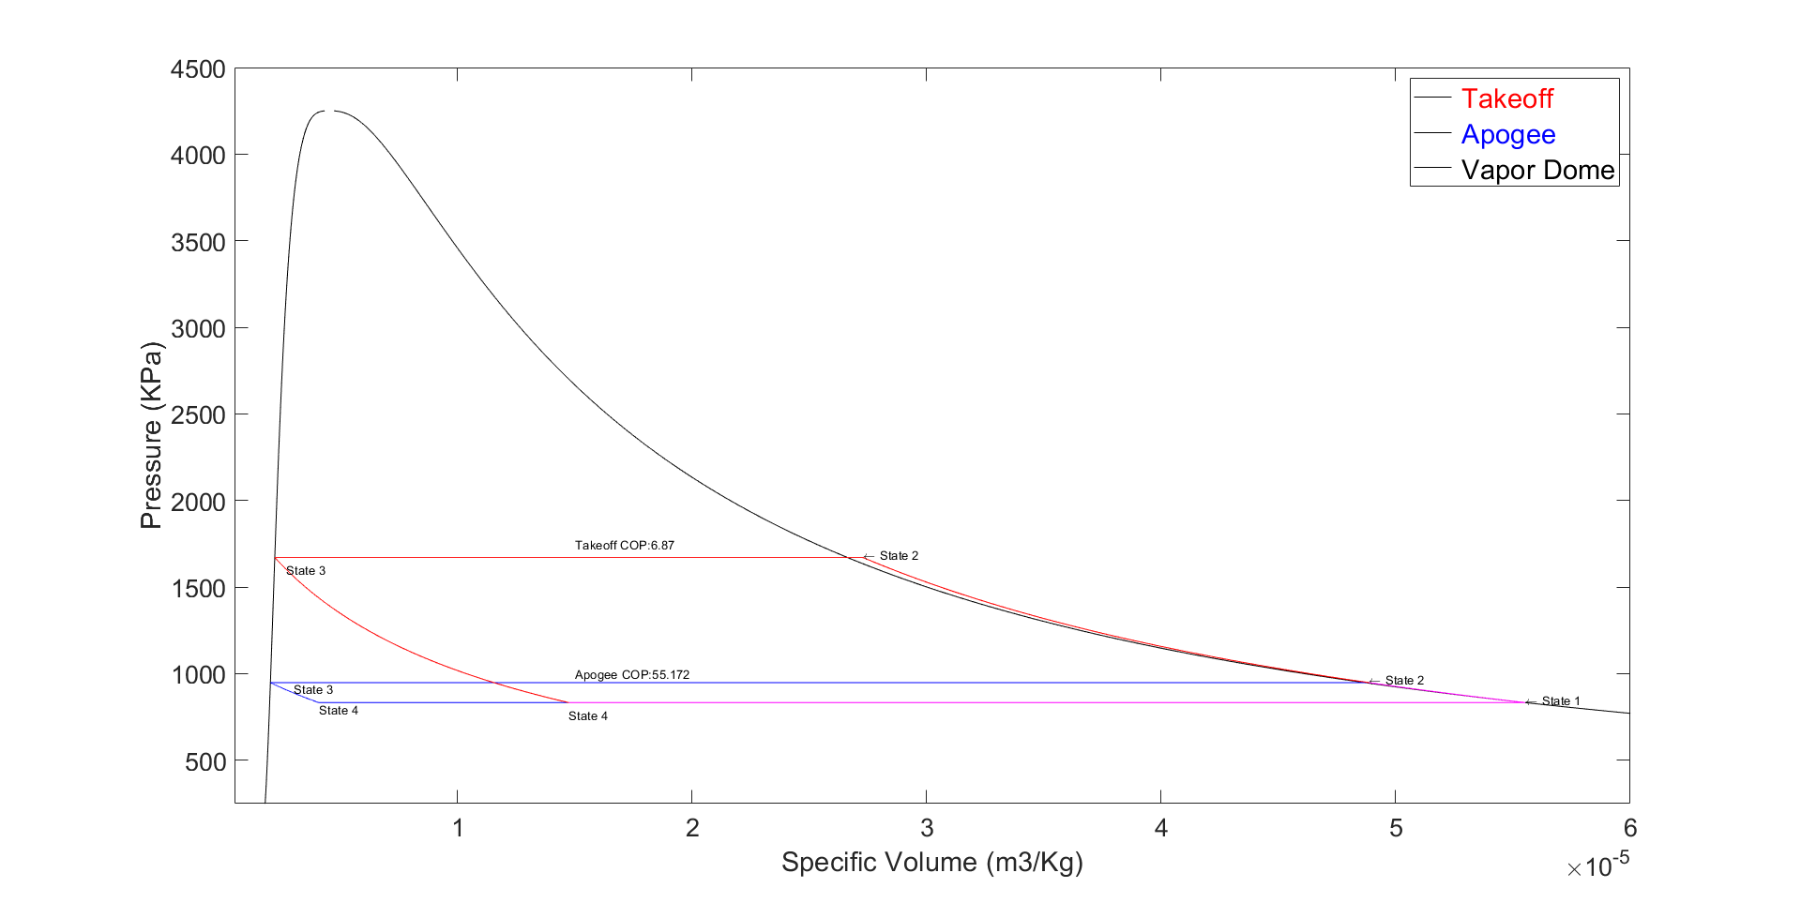
Figure 10 - P-v Refrigeration Cycle of R290

MATLAB Code

The code below utilized a single script with desired for loops to create the information necessary to write this report. Functions could have been used, but it would not have made debugging as easy, and was not necessary for the structure of this code.

clear all; close all
clc;

%%%%%%%%%%%%%
% COP vs Outside Temperature for 3 Different Refrigerants
%%%%%%%%%%%%%

Working_Fluid_1 = {'R410a'};
Working_Fluid_2 = {'R290'};
Working_Fluid_3 = {'Ammonia'};
Working_Fluid_4 = {'Water'};
Working_Fluid_5 = {'R22'};
Working_Fluid_6 = {'R114'};
Working_Fluid_7 = {'IsoButane'};
Working_Fluid_8 = {'MDM'};
Working_Fluid_9 = {'R12'};
Working_Fluid_10 = {'R143a'};
Working_Fluid_11 = {'R123'};
Working_Fluid_12 = {'Acetone'};
Working_Fluid_13 = {'R404a'};
Working_Fluid_14 = {'R125'};
Working_Fluid_15 = {'R134a'};
Working_Fluids = [Working_Fluid_1,Working_Fluid_2,Working_Fluid_3,Working_Fluid_4,Working_Fluid_5,Working_Fluid_6,Working_Fluid_7,...
Working_Fluid_8,Working_Fluid_9,Working_Fluid_10,Working_Fluid_11,Working_Fluid_12,Working_Fluid_13,Working_Fluid_14,Working_Fluid_15];

Outside_Temperature = linspace(273 + 18 - 1, 273 + 50 + 2, 1000);

COP_R410a = zeros(1000);
COP_R290 = zeros(1000);
COP_Ammonia = zeros(1000);
COP_Water = zeros(1000);
COP_R22 = zeros(1000);
COP_R114 = zeros(1000);
COP_IsoButane = zeros(1000);
COP_MDM = zeros(1000);
COP_R12 = zeros(1000);
COP_R143a = zeros(1000);
COP_R123 = zeros(1000);
COP_Acetone = zeros(1000);
COP_R404a = zeros(1000);
COP_R125 = zeros(1000);
COP_R134a = zeros(1000);

MFR_R410a = zeros(1000);
MFR_R290 = zeros(1000);
MFR_Ammonia = zeros(1000);
MFR_Water = zeros(1000);
MFR_R22 = zeros(1000);
MFR_R114 = zeros(1000);
MFR_IsoButane = zeros(1000);
MFR_MDM = zeros(1000);
MFR_R12 = zeros(1000);
MFR_R143a = zeros(1000);
MFR_R123 = zeros(1000);
MFR_Acetone = zeros(1000);
MFR_R404a = zeros(1000);
MFR_R125 = zeros(1000);
MFR_R134a = zeros(1000);

j=1;
for i = Working_Fluids
k=1;
for temps = Outside_Temperature

Working_Fluid_1 = Working_Fluids{j};
%%%%%%%%%%%%%
% Constants for the Refridgeration Cycle for Durham, NH
%%%%%%%%%%%%%

Cold_Space = 273+20; % Kelvin - Temperature of Cold Space of Pod

%%%%%%%%%%%%%
% Location 1 - Between Evaporator and Compressor
%%%%%%%%%%%%%

% Finding all values of the fluid at location 1
Q_1 = 1; % Saturated Vapor
T_1 = Cold_Space; % Temperature from 4 to 1
P_1 = CoolProp.PropsSI('P', 'T', T_1, 'Q', Q_1, Working_Fluid_1);
H_1 = CoolProp.PropsSI('H', 'T', T_1, 'Q', Q_1, Working_Fluid_1);
U_1 = CoolProp.PropsSI('U', 'T', T_1, 'Q', Q_1, Working_Fluid_1);
S_1 = CoolProp.PropsSI('S', 'T', T_1, 'Q', Q_1, Working_Fluid_1);
V_1 = 1/CoolProp.PropsSI('D', 'T', T_1, 'Q', Q_1, Working_Fluid_1);

%%%%%%%%%%%%%
% Location 3 - Between Condensor and Expansion Valve - Saturated Liquid
%%%%%%%%%%%%%

% Finding all values of the fluid at location 3
Q_3 = 0; % Saturated Liquid
T_3_Summer = temps + 5; % Temperature from 4 to 1
P_3_Summer = CoolProp.PropsSI('P', 'T', T_3_Summer, 'Q', Q_3, Working_Fluid_1);
H_3_Summer = CoolProp.PropsSI('H', 'T', T_3_Summer, 'Q', Q_3, Working_Fluid_1);
U_3_Summer = CoolProp.PropsSI('U', 'T', T_3_Summer, 'Q', Q_3, Working_Fluid_1);
S_3_Summer = CoolProp.PropsSI('S', 'T', T_3_Summer, 'Q', Q_3, Working_Fluid_1);
V_3_Summer = 1/CoolProp.PropsSI('D', 'T', T_3_Summer, 'Q', Q_3, Working_Fluid_1);

%%%%%%%%%%%%%
% Location 2 - Between Condensor and Expansion Valve Super-Heated Vapor
%%%%%%%%%%%%%

% Finding all values of the fluid at location 2
S_2_Summer = S_1; % Constant Entropy
P_2_Summer = P_3_Summer; % Constant Pressure Isobar
T_2_Summer = CoolProp.PropsSI('T', 'P', P_2_Summer, 'S', S_2_Summer, Working_Fluid_1);
H_2_Summer = CoolProp.PropsSI('H', 'P', P_2_Summer, 'S', S_2_Summer, Working_Fluid_1);
U_2_Summer = CoolProp.PropsSI('U', 'P', P_2_Summer, 'S', S_2_Summer, Working_Fluid_1);
V_2_Summer = 1/CoolProp.PropsSI('D', 'P', P_2_Summer, 'S', S_2_Summer, Working_Fluid_1);

%%%%%%%%%%%%%
% Location 2a - On Vapor Dome During the process 2 to 3 in condensor
%%%%%%%%%%%%%

% Finding all values of the fluid at location 2a
Q_2a=1; % On Vapor Dome as Saturdated Vapor
P_2a_Summer = P_2_Summer; % Isobar = Constant Pressure
T_2a_Summer = T_3_Summer; % Constant Temperature from T3
S_2a_Summer = CoolProp.PropsSI('S', 'P', P_2a_Summer, 'Q', Q_2a, Working_Fluid_1);
H_2a_Summer = CoolProp.PropsSI('H', 'P', P_2a_Summer, 'Q', Q_2a, Working_Fluid_1);
U_2a_Summer = CoolProp.PropsSI('U', 'P', P_2a_Summer, 'Q', Q_2a, Working_Fluid_1);
V_2a_Summer = 1/CoolProp.PropsSI('D', 'P', P_2a_Summer, 'Q', Q_2a, Working_Fluid_1);

%%%%%%%%%%%%%
% Location 4 - Mixture between the expansion valve and evaporator
%%%%%%%%%%%%%

% Finding all values of the fluid at location 4
T_4 = T_1; % Constant Temperature from 4 to 1 Process
H_4_Summer = H_3_Summer; % Expansion Valve is ~ constant enthalpy process
P_4_Summer = P_1; % Isobaric Process
U_4_Summer = CoolProp.PropsSI('U', 'P', P_4_Summer, 'H', H_4_Summer, Working_Fluid_1);
S_4_Summer = CoolProp.PropsSI('S', 'P', P_4_Summer, 'H', H_4_Summer, Working_Fluid_1);
V_4_Summer = 1/CoolProp.PropsSI('D', 'P', P_4_Summer, 'H', H_4_Summer, Working_Fluid_1);

% Co-Efficient of Performance where COP = (QL/Wnet) = ((h1-h4)/(h2-h1))

COP_Summer = (H_1 - H_4_Summer)/(H_2_Summer - H_1);

% Mass Flow Rate where flow rate = Cooling Capacity / Q_L

dH_Evaporator_Summer = H_1 - H_4_Summer;
Cooling_Capacity = 500; % Watts
Mass_Flow_Rate_Summer = Cooling_Capacity / dH_Evaporator_Summer;

% Compressor Power

Compressor_Power_Summer = Mass_Flow_Rate_Summer * (H_2_Summer - H_1); % [J/s]

if j == 1
COP_R410a(k) = COP_Summer;
MFR_R410a(k) = Mass_Flow_Rate_Summer;
elseif j == 2
COP_R290(k) = COP_Summer;
MFR_R290(k) = Mass_Flow_Rate_Summer;
elseif j == 3
COP_Ammonia(k) = COP_Summer;
MFR_Ammonia(k) = Mass_Flow_Rate_Summer;
elseif j == 4
COP_Water(k) = COP_Summer;
MFR_Water(k) = Mass_Flow_Rate_Summer;
elseif j == 5
COP_R22(k) = COP_Summer;
MFR_R22(k) = Mass_Flow_Rate_Summer;
elseif j == 6
COP_R114(k) = COP_Summer;
MFR_R114(k) = Mass_Flow_Rate_Summer;
elseif j == 7
COP_IsoButane(k) = COP_Summer;
MFR_IsoButane(k) = Mass_Flow_Rate_Summer;
elseif j == 8
COP_MDM(k) = COP_Summer;
MFR_MDM(k) = Mass_Flow_Rate_Summer;
elseif j == 9
COP_R12(k) = COP_Summer;
MFR_R12(k) = Mass_Flow_Rate_Summer;
elseif j == 10
COP_R143a(k) = COP_Summer;
MFR_R143a(k) = Mass_Flow_Rate_Summer;
elseif j == 11
COP_R123(k) = COP_Summer;
MFR_R123(k) = Mass_Flow_Rate_Summer;
elseif j == 12
COP_Acetone(k) = COP_Summer;
MFR_Acetone(k) = Mass_Flow_Rate_Summer;
elseif j == 13
COP_R404a(k) = COP_Summer;
MFR_R404a(k) = Mass_Flow_Rate_Summer;
elseif j == 14
COP_R125(k) = COP_Summer;
MFR_R125(k) = Mass_Flow_Rate_Summer;
else
COP_R134a(k) = COP_Summer;
MFR_R134a(k) = Mass_Flow_Rate_Summer;
end

k=k+1;
end
j=j+1;
end

for pos = 1:1000
COP_R410a(pos) = abs(COP_R410a(pos));
COP_R290(pos) = abs(COP_R290(pos));
COP_Ammonia(pos) = abs(COP_Ammonia(pos));
COP_Water(pos) = abs(COP_Water(pos));
COP_R22(pos) = abs(COP_R22(pos));
COP_R114(pos) = abs(COP_R114(pos));
COP_IsoButane(pos) = abs(COP_IsoButane(pos));
COP_MDM(pos) = abs(COP_MDM(pos));
COP_R12(pos) = abs(COP_R12(pos));
COP_R143a(pos) = abs(COP_R143a(pos));
COP_R123(pos) = abs(COP_R123(pos));
COP_Acetone(pos) = abs(COP_Acetone(pos));
COP_R404a(pos) = abs(COP_R404a(pos));
COP_R125(pos) = abs(COP_R125(pos));
COP_R134a(pos) = abs(COP_R134a(pos));
end

% Plotting COP vs Outside Temperature
figure(1)
% R Refrigerants
semilogx(COP_R410a,Outside_Temperature-273,'r',COP_R290,Outside_Temperature-273,'r')
semilogx(COP_R404a,Outside_Temperature-273,'r',COP_R125,Outside_Temperature-273,'r',COP_R134a,Outside_Temperature-273,'r',COP_R22,Outside_Temperature-273,'r')
semilogx(COP_R123,Outside_Temperature-273,'r',COP_R12,Outside_Temperature-273,'r',COP_R143a,Outside_Temperature-273,'r',COP_R114,Outside_Temperature-273,'r')
hold on
semilogx(COP_Water,Outside_Temperature-273,'b')
semilogx(COP_IsoButane,Outside_Temperature-273,'k')
semilogx(COP_MDM,Outside_Temperature-273,'m')
semilogx(COP_Acetone,Outside_Temperature-273,'g',COP_Ammonia,Outside_Temperature-273,'g')

plot([5,100],[20,20],[5,150],[50,50])
hold off
text(20,49,'Takeoff Environment Temperature')
text(20,19,'Cold Space Environment Temperature')

% Plot Syntax

xlabel('Coefficient of Performance','FontSize',22)
set(gca,'fontsize',20)
ylabel('Temperature','FontSize',22)
set(gca,'fontsize',20)
xlim([5 100])
ylim([15 55])
lgd = legend('\color{red} R-Refrigerants','\color{blue} Water Refrigerants','\color{black} IsoButane Refrigerants','\color{magenta} MDM Refrigerants','\color{green} Acetone/Ammonia');
lgd.FontSize = 22;
hold off

% Plotting COP vs Outside Temperature
figure(2)
% R Refrigerants
semilogx(COP_R410a,Outside_Temperature-273,'r',COP_R290,Outside_Temperature-273,'r')
semilogx(COP_R404a,Outside_Temperature-273,'r',COP_R125,Outside_Temperature-273,'r',COP_R134a,Outside_Temperature-273,'r',COP_R22,Outside_Temperature-273,'r')
semilogx(COP_R123,Outside_Temperature-273,'r',COP_R12,Outside_Temperature-273,'r',COP_R143a,Outside_Temperature-273,'r',COP_R114,Outside_Temperature-273,'r')
hold on
semilogx(COP_Water,Outside_Temperature-273,'b')
semilogx(COP_IsoButane,Outside_Temperature-273,'k')
semilogx(COP_MDM,Outside_Temperature-273,'m')
semilogx(COP_Acetone,Outside_Temperature-273,'g',COP_Ammonia,Outside_Temperature-273,'g')

plot([5,100],[20,20],[5,150],[50,50])
hold off
text(20,49,'Takeoff Environment Temperature')
text(20,19,'Cold Space Environment Temperature')

% Plot Syntax
xlabel('Coefficient of Performance','FontSize',22)
set(gca,'fontsize',20)
ylabel('Temperature','FontSize',22)
set(gca,'fontsize',20)
xlim([5 100])
ylim([15 55])
hold off
% Create a list from best to worst refrigerants in respect to its COP

COP_R410a_Max = COP_R410a(915); % The index selection for Takeoff Temperature
COP_R290_Max = COP_R290(915);
COP_Ammonia_Max = COP_Ammonia(915);
COP_Water_Max = COP_Water(915);
COP_R22_Max = COP_R22(915);
COP_R114_Max = COP_R114(915);
COP_IsoButane_Max = COP_IsoButane(915);
COP_MDM_Max = COP_MDM(915);
COP_R12_Max = COP_R12(915);
COP_R143a_Max = COP_R143a(915);
COP_R123_Max = COP_R123(915);
COP_Acetone_Max = COP_Acetone(915);
COP_R404a_Max = COP_R404a(915);
COP_R125_Max = COP_R125(915);
COP_R134a_Max = COP_R134a(915);

COP_TakeOff_Sorted =sortrows({COP_R410a_Max,'R410a';COP_R290_Max,'R290';COP_Ammonia_Max,'Ammonia';COP_Water_Max,'Water';COP_R22_Max,'R22';COP_R114_Max,'R114';...
COP_IsoButane_Max,'IsoButane';COP_MDM_Max,'MDM';COP_R12_Max,'R12';COP_R143a_Max,'R143a';COP_R123_Max,'R123';COP_Acetone_Max,'Acetone';COP_R404a_Max,'R404a';COP_R125_Max,'R125';COP_R134a_Max,'R125'},1);
figure(3)
plot(Outside_Temperature-273,MFR_Acetone,'r',Outside_Temperature-273,MFR_R123,'b',Outside_Temperature-273,MFR_Ammonia,'m',Outside_Temperature-273,MFR_R290,'g')
xlabel('Temperature (C)','FontSize',22)
set(gca,'fontsize',20)
ylabel('Mass Flow Rate (kg/s)','FontSize',22)
set(gca,'fontsize',20)
lgd = legend('\color{red} Acetone','\color{blue} R123','\color{magenta} Ammonia','\color{green} R290');
lgd.FontSize = 22;
hold off

figure(4)
plot(Outside_Temperature-273,MFR_Acetone,'r',Outside_Temperature-273,MFR_R123,'b',Outside_Temperature-273,MFR_Ammonia,'m',Outside_Temperature-273,MFR_R290,'g')
xlabel('Temperature (C)','FontSize',22)
set(gca,'fontsize',20)
ylabel('Mass Flow Rate (kg/s)','FontSize',22)
set(gca,'fontsize',20)

hold off

%Once the best COPs are chosen from the above analysis, the final full analysis of the desired working fluid is calculated and plotted

Working_Fluid_1 = {'R290'};
Working_Fluid_1 = Working_Fluid_1{1};
Max_Pressure = 4250000;

%%%%%%%%%%%%%
% Constants for the Refridgeration Cycle for Durham, NH
%%%%%%%%%%%%%

Cold_Space = 273+20; % Kelvin - Temperature of Cold Space of Pod
Hot_Space_Liftoff = 273 + 49; % Hottest Outside Environment
Cold_Space_Apogee = 273 - 18; % Coldest Outside Environment

Summer is used to refer to Liftoff, and Winter is for Apogee %%%
%%%%%%%%%%%%%
% Location 1 - Between Evaporator and Compressor
%%%%%%%%%%%%%

% Finding all values of the fluid at location 1
Q_1 = 1; % Saturated Vapor
T_1 = Cold_Space; % Temperature from 4 to 1
P_1 = CoolProp.PropsSI('P', 'T', T_1, 'Q', Q_1, Working_Fluid_1);
H_1 = CoolProp.PropsSI('H', 'T', T_1, 'Q', Q_1, Working_Fluid_1);
U_1 = CoolProp.PropsSI('U', 'T', T_1, 'Q', Q_1, Working_Fluid_1);
S_1 = CoolProp.PropsSI('S', 'T', T_1, 'Q', Q_1, Working_Fluid_1);
V_1 = 1/CoolProp.PropsSI('D', 'T', T_1, 'Q', Q_1, Working_Fluid_1);

Q_1_Apogee = 1; % Saturated Vapor
T_1_Apogee = Cold_Space; % Temperature from 4 to 1
P_1_Apogee = CoolProp.PropsSI('P', 'T', T_1_Apogee, 'Q', Q_1, Working_Fluid_1);
H_1_Apogee = CoolProp.PropsSI('H', 'T', T_1_Apogee, 'Q', Q_1, Working_Fluid_1);
U_1_Apogee = CoolProp.PropsSI('U', 'T', T_1_Apogee, 'Q', Q_1, Working_Fluid_1);
S_1_Apogee = CoolProp.PropsSI('S', 'T', T_1_Apogee, 'Q', Q_1, Working_Fluid_1);
V_1_Apogee = 1/CoolProp.PropsSI('D', 'T', T_1_Apogee, 'Q', Q_1, Working_Fluid_1);

%%%%%%%%%%%%%
% Location 3 - Between Condensor and Expansion Valve - Saturated Liquid
%%%%%%%%%%%%%

% Finding all values of the fluid at location 3
Q_3 = 0; % Saturated Liquid
T_3_Summer = Hot_Space_Liftoff; % Temperature from 4 to 1
P_3_Summer = CoolProp.PropsSI('P', 'T', T_3_Summer, 'Q', Q_3, Working_Fluid_1);
H_3_Summer = CoolProp.PropsSI('H', 'T', T_3_Summer, 'Q', Q_3, Working_Fluid_1);
U_3_Summer = CoolProp.PropsSI('U', 'T', T_3_Summer, 'Q', Q_3, Working_Fluid_1);
S_3_Summer = CoolProp.PropsSI('S', 'T', T_3_Summer, 'Q', Q_3, Working_Fluid_1);
V_3_Summer = 1/CoolProp.PropsSI('D', 'T', T_3_Summer, 'Q', Q_3, Working_Fluid_1);

T_3_Winter = Cold_Space + 5; % Temperature from 4 to 1
P_3_Winter = CoolProp.PropsSI('P', 'T', T_3_Winter, 'Q', Q_3, Working_Fluid_1);
H_3_Winter = CoolProp.PropsSI('H', 'T', T_3_Winter, 'Q', Q_3, Working_Fluid_1);
U_3_Winter = CoolProp.PropsSI('U', 'T', T_3_Winter, 'Q', Q_3, Working_Fluid_1);
S_3_Winter = CoolProp.PropsSI('S', 'T', T_3_Winter, 'Q', Q_3, Working_Fluid_1);
V_3_Winter = 1/CoolProp.PropsSI('D', 'T', T_3_Winter, 'Q', Q_3, Working_Fluid_1);

%%%%%%%%%%%%%
% Location 2 - Between Condensor and Expansion Valve Super-Heated Vapor
%%%%%%%%%%%%%

% Finding all values of the fluid at location 2
S_2_Summer = S_1; % Constant Entropy
P_2_Summer = P_3_Summer; % Constant Pressure Isobar
T_2_Summer = CoolProp.PropsSI('T', 'P', P_2_Summer, 'S', S_2_Summer, Working_Fluid_1);
H_2_Summer = CoolProp.PropsSI('H', 'P', P_2_Summer, 'S', S_2_Summer, Working_Fluid_1);
U_2_Summer = CoolProp.PropsSI('U', 'P', P_2_Summer, 'S', S_2_Summer, Working_Fluid_1);
V_2_Summer = 1/CoolProp.PropsSI('D', 'P', P_2_Summer, 'S', S_2_Summer, Working_Fluid_1);

P_2_Winter = P_3_Winter; % Constant Pressure Isobar
S_2_Winter = S_1_Apogee; % Constant Entropy
T_2_Winter = CoolProp.PropsSI('T', 'P', P_2_Winter, 'S', S_2_Winter, Working_Fluid_1);
H_2_Winter = CoolProp.PropsSI('H', 'P', P_2_Winter, 'S', S_2_Winter, Working_Fluid_1);
U_2_Winter = CoolProp.PropsSI('U', 'P', P_2_Winter, 'S', S_2_Winter, Working_Fluid_1);
V_2_Winter = 1/CoolProp.PropsSI('D', 'P', P_2_Winter, 'S', S_2_Winter, Working_Fluid_1);

%%%%%%%%%%%%%
% Location 2a - On Vapor Dome During the process 2 to 3 in condensor
%%%%%%%%%%%%%

% Finding all values of the fluid at location 2a
Q_2a=1; % On Vapor Dome as Saturdated Vapor
P_2a_Summer = P_2_Summer; % Isobar = Constant Pressure
T_2a_Summer = T_3_Summer; % Constant Temperature from T3
S_2a_Summer = CoolProp.PropsSI('S', 'P', P_2a_Summer, 'Q', Q_2a, Working_Fluid_1);
H_2a_Summer = CoolProp.PropsSI('H', 'P', P_2a_Summer, 'Q', Q_2a, Working_Fluid_1);
U_2a_Summer = CoolProp.PropsSI('U', 'P', P_2a_Summer, 'Q', Q_2a, Working_Fluid_1);
V_2a_Summer = 1/CoolProp.PropsSI('D', 'P', P_2a_Summer, 'Q', Q_2a, Working_Fluid_1);

P_2a_Winter = P_2_Winter; % Isobar = Constant Pressure
T_2a_Winter = T_3_Winter; % Constant Temperature from T3
S_2a_Winter = CoolProp.PropsSI('S', 'P', P_2a_Winter, 'Q', Q_2a, Working_Fluid_1);
H_2a_Winter = CoolProp.PropsSI('H', 'P', P_2a_Winter, 'Q', Q_2a, Working_Fluid_1);
U_2a_Winter = CoolProp.PropsSI('U', 'P', P_2a_Winter, 'Q', Q_2a, Working_Fluid_1);
V_2a_Winter = 1/CoolProp.PropsSI('D', 'P', P_2a_Winter, 'Q', Q_2a, Working_Fluid_1);

%%%%%%%%%%%%%
% Location 4 - Mixture between the expansion valve and evaporator
%%%%%%%%%%%%%

% Finding all values of the fluid at location 4
T_4 = T_1; % Constant Temperature from 4 to 1 Process
H_4_Summer = H_3_Summer; % Expansion Valve is ~ constant enthalpy process
P_4_Summer = P_1; % Isobaric Process
U_4_Summer = CoolProp.PropsSI('U', 'P', P_4_Summer, 'H', H_4_Summer, Working_Fluid_1);
S_4_Summer = CoolProp.PropsSI('S', 'P', P_4_Summer, 'H', H_4_Summer, Working_Fluid_1);
V_4_Summer = 1/CoolProp.PropsSI('D', 'P', P_4_Summer, 'H', H_4_Summer, Working_Fluid_1);

T_4_Winter = T_1_Apogee; % Constant Temperature from 4 to 1 Process
H_4_Winter = H_3_Winter; % Expansion Valve is ~ constant enthalpy process
P_4_Winter = P_1_Apogee; % Isobaric Process
U_4_Winter = CoolProp.PropsSI('U', 'P', P_4_Winter, 'H', H_4_Winter, Working_Fluid_1);
S_4_Winter = CoolProp.PropsSI('S', 'P', P_4_Winter, 'H', H_4_Winter, Working_Fluid_1);
V_4_Winter = 1/CoolProp.PropsSI('D', 'P', P_4_Winter, 'H', H_4_Winter, Working_Fluid_1);

%%%%%%%%%%%%%
% Calculations of the Vapor Dome for the Refridgeration Cycle
% Will be plotted as a T-s and P-h Diagram
% Two curves will be plotted for each graph, one for the Saturated Liquid and one for Saturdated Vapor Sections
%%%%%%%%%%%%%

% Constant Variables and Pressure Array to Calculate Graph Values
Q_SL = 0; % Saturated Liquid
Q_SV = 1; % Saturated Vapor
P_SL_SV = linspace(100000,Max_Pressure,1000); % Pressures for the Saturated Liquid Curve

T_SL = zeros(length(P_SL_SV));
S_SL = zeros(length(P_SL_SV));
H_SL = zeros(length(P_SL_SV));
V_SL = zeros(length(P_SL_SV));
T_SV = zeros(length(P_SL_SV));
S_SV = zeros(length(P_SL_SV));
H_SV = zeros(length(P_SL_SV));
V_SV = zeros(length(P_SL_SV));

% Looping 1000 times to provide values for the Vapor Dome Curves for T, s, h and v. P array will be graphed with them
for index=1:1000
T_SL(index) = CoolProp.PropsSI('T', 'P', P_SL_SV(index), 'Q', Q_SL, Working_Fluid_1) -273;
S_SL(index) = CoolProp.PropsSI('S', 'P', P_SL_SV(index), 'Q', Q_SL, Working_Fluid_1);
H_SL(index) = CoolProp.PropsSI('H', 'P', P_SL_SV(index), 'Q', Q_SL, Working_Fluid_1);
V_SL(index) = 1/CoolProp.PropsSI('D','P',P_SL_SV(index), 'Q', Q_SL, Working_Fluid_1);
T_SV(index) = CoolProp.PropsSI('T', 'P', P_SL_SV(index), 'Q', Q_SV, Working_Fluid_1) -273;
S_SV(index) = CoolProp.PropsSI('S', 'P', P_SL_SV(index), 'Q', Q_SV, Working_Fluid_1);
H_SV(index) = CoolProp.PropsSI('H', 'P', P_SL_SV(index), 'Q', Q_SV, Working_Fluid_1);
V_SV(index) = 1/CoolProp.PropsSI('D','P',P_SL_SV(index), 'Q', Q_SV, Working_Fluid_1);
end

%%%%%%%%%%%%%
% Calculations of Every Point during the Refridgeration Cycle
%%%%%%%%%%%%%

% Compressor Points - Points 1 to 2 - Constant Entropy

S_Compressor_Liftoff = S_1; % Constant Entropy Process
S_Compressor_Apogee = S_1_Apogee; % Constant Entropy Process
P_Compressor_Summer = linspace(P_1,P_2_Summer,1000);
P_Compressor_Winter = linspace(P_1_Apogee,P_2_Winter,1000);
T_Compressor_Summer = zeros(length(P_Compressor_Summer));
T_Compressor_Winter = zeros(length(P_Compressor_Summer));
S_Compressor_Summer = zeros(length(P_Compressor_Summer));
S_Compressor_Winter = zeros(length(P_Compressor_Summer));
H_Compressor_Summer = zeros(length(P_Compressor_Summer));
H_Compressor_Winter = zeros(length(P_Compressor_Summer));
V_Compressor_Summer = zeros(length(P_Compressor_Summer));
V_Compressor_Winter = zeros(length(P_Compressor_Summer));

for index = 1:1000
T_Compressor_Summer(index) = CoolProp.PropsSI('T', 'P', P_Compressor_Summer(index), 'S', S_Compressor_Liftoff, Working_Fluid_1) - 273;
T_Compressor_Winter(index) = CoolProp.PropsSI('T', 'P', P_Compressor_Winter(index), 'S', S_Compressor_Apogee, Working_Fluid_1) - 273;
S_Compressor_Summer(index) = CoolProp.PropsSI('S', 'P', P_Compressor_Summer(index), 'S', S_Compressor_Liftoff, Working_Fluid_1);
S_Compressor_Winter(index) = CoolProp.PropsSI('S', 'P', P_Compressor_Winter(index), 'S', S_Compressor_Apogee, Working_Fluid_1);
H_Compressor_Summer(index) = CoolProp.PropsSI('H', 'P', P_Compressor_Summer(index), 'S', S_Compressor_Liftoff, Working_Fluid_1);
H_Compressor_Winter(index) = CoolProp.PropsSI('H', 'P', P_Compressor_Winter(index), 'S', S_Compressor_Apogee, Working_Fluid_1);
V_Compressor_Summer(index) = 1/CoolProp.PropsSI('D', 'P', P_Compressor_Summer(index), 'S', S_Compressor_Liftoff, Working_Fluid_1);
V_Compressor_Winter(index) = 1/CoolProp.PropsSI('D', 'P', P_Compressor_Winter(index), 'S', S_Compressor_Apogee, Working_Fluid_1);
end

% Condensor - Points 2 to 2a - Constant Pressure

P_Condensor_Summer = P_2_Summer; % Constant Pressure Process
P_Condensor_Winter = P_2_Winter; % Constant Pressure Process
T_Condensor_Summer = linspace(T_2_Summer,T_2a_Summer+.25,1000); % Added constant .25 so it does not go to the mixture
T_Condensor_Winter = linspace(T_2_Winter,T_2a_Winter+.25,1000); % Added constant .25 so it does not go to the mixture
S_Condensor_Summer = zeros(length(P_Condensor_Summer));
S_Condensor_Winter = zeros(length(P_Condensor_Summer));
H_Condensor_Summer = zeros(length(P_Condensor_Summer));
H_Condensor_Winter = zeros(length(P_Condensor_Summer));
V_Condensor_Summer = zeros(length(P_Condensor_Summer));
V_Condensor_Winter = zeros(length(P_Condensor_Summer));
for index = 1:1000
S_Condensor_Summer(index) = CoolProp.PropsSI('S', 'T', T_Condensor_Summer(index), 'P', P_Condensor_Summer, Working_Fluid_1);
S_Condensor_Winter(index) = CoolProp.PropsSI('S', 'T', T_Condensor_Winter(index), 'P', P_Condensor_Winter, Working_Fluid_1);
H_Condensor_Summer(index) = CoolProp.PropsSI('H', 'T', T_Condensor_Summer(index), 'P', P_Condensor_Summer, Working_Fluid_1);
H_Condensor_Winter(index) = CoolProp.PropsSI('H', 'T', T_Condensor_Winter(index), 'P', P_Condensor_Winter, Working_Fluid_1);
V_Condensor_Summer(index) = 1/CoolProp.PropsSI('D', 'T', T_Condensor_Summer(index), 'P', P_Condensor_Summer, Working_Fluid_1);
V_Condensor_Winter(index) = 1/CoolProp.PropsSI('D', 'T', T_Condensor_Winter(index), 'P', P_Condensor_Winter, Working_Fluid_1);
end

% Condensor - Points 2a to 3 - Constant Pressure - Straight Line inside Vapor Dome

T_Condensora_Summer = [T_2a_Summer,T_3_Summer]; % Constant Temperature
T_Condensora_Winter = [T_2a_Winter,T_3_Winter]; % Constant Temperature
P_Condensora_Summer = [P_2a_Summer,P_3_Summer];
P_Condensora_Winter = [P_2a_Winter,P_3_Winter];
S_Condensora_Summer = [S_2a_Summer,S_3_Summer];
S_Condensora_Winter = [S_2a_Winter,S_3_Winter];
H_Condensora_Summer = [H_2a_Summer,H_3_Summer];
H_Condensora_Winter = [H_2a_Winter,H_3_Winter];
V_Condensora_Summer = [V_2a_Summer,V_3_Summer];
V_Condensora_Winter = [V_2a_Winter,V_3_Winter];

% Expansion Valve - Points 3 to 4 - Constant Enthalpy

H_Valve_Summer = H_3_Summer; % Constant Enthlpy Process
H_Valve_Winter = H_3_Winter; % Constant Enthlpy Process
P_Valve_Summer = linspace(P_3_Summer,P_4_Summer,1000); % Added constant .5 so it does not go to the mixture
P_Valve_Winter = linspace(P_3_Winter,P_4_Winter,1000); % Added constant .5 so it does not go to the mixture
S_Valve_Summer = zeros(length(P_Valve_Summer));
S_Valve_Winter = zeros(length(P_Valve_Summer));
T_Valve_Summer = zeros(length(P_Valve_Summer));
T_Valve_Winter = zeros(length(P_Valve_Summer));
V_Valve_Summer = zeros(length(P_Valve_Summer));
V_Valve_Winter = zeros(length(P_Valve_Summer));
for index = 1:1000
S_Valve_Summer(index) = CoolProp.PropsSI('S', 'H', H_Valve_Summer, 'P', P_Valve_Summer(index), Working_Fluid_1);
S_Valve_Winter(index) = CoolProp.PropsSI('S', 'H', H_Valve_Winter, 'P', P_Valve_Winter(index), Working_Fluid_1);
T_Valve_Summer(index) = CoolProp.PropsSI('T', 'H', H_Valve_Summer, 'P', P_Valve_Summer(index), Working_Fluid_1);
T_Valve_Winter(index) = CoolProp.PropsSI('T', 'H', H_Valve_Winter, 'P', P_Valve_Winter(index), Working_Fluid_1);
V_Valve_Summer(index) = 1/CoolProp.PropsSI('D', 'H', H_Valve_Summer, 'P', P_Valve_Summer(index), Working_Fluid_1);
V_Valve_Winter(index) = 1/CoolProp.PropsSI('D', 'H', H_Valve_Winter, 'P', P_Valve_Winter(index), Working_Fluid_1);
end

% Evaporator - Points 4 to 1 - Constant Temperature - Straight Line inside Vapor Dome

T_Evaporator_Summer = [T_4,T_1]; % Constant Temperature
T_Evaporator_Winter = [T_4_Winter,T_1_Apogee]; % Constant Temperature
P_Evaporator_Summer = [P_4_Summer,P_1];
P_Evaporator_Winter = [P_4_Winter,P_1_Apogee];
S_Evaporator_Summer = [S_4_Summer,S_1];
S_Evaporator_Winter = [S_4_Winter,S_1_Apogee];
H_Evaporator_Summer = [H_4_Summer,H_1];
H_Evaporator_Winter = [H_4_Winter,H_1_Apogee];
V_Evaporator_Summer = [V_4_Summer,V_1];
V_Evaporator_Winter = [V_4_Winter,V_1_Apogee];

%%%%%%%%%%%%%
% Calculation COP for each temperature
%%%%%%%%%%%%%

COP_Summer = (H_1 - H_4_Summer)/(H_2_Summer - H_1);
COP_Winter = (H_1_Apogee - H_4_Winter)/(H_2_Winter - H_1_Apogee);

%%%%%%%%%%%%%
% Graphing the T-s and P-h and P-vGraphs with Vapor Dome and Labels
%%%%%%%%%%%%%

% T-s Graph for the Summer
figure(5)
% Vapor Dome
plot(S_SL/1000,T_SL,'k',S_SV/1000,T_SV,'k')
hold on
% Processes

% Winter
plot(S_Compressor_Winter/1000,T_Compressor_Winter,'b',S_Condensor_Winter/1000, T_Condensor_Winter-273,'b',S_Condensora_Winter/1000, T_Condensora_Winter-273,'b',S_Valve_Winter/1000,T_Valve_Winter-273,'b',S_Evaporator_Winter/1000, T_Evaporator_Winter-273,'b')
text(S_1_Apogee/1000,T_1_Apogee-273, '\leftarrow State 1')
text(S_2_Winter/1000,T_2_Winter-273, '\leftarrow State 2')
text(S_2a_Winter/1000-.03,T_2a_Winter-273-1, 'State 2a','FontSize', 8)
text(S_3_Winter/1000-.06,T_3_Winter-273, 'State 3')
text(S_4_Winter/1000-.02,T_4_Winter-273-1, 'State 4')
text(1.8,27, strcat('Apogee COP: ' , num2str(COP_Winter)))

% Summer
plot(S_Compressor_Summer/1000,T_Compressor_Summer,'r',S_Condensor_Summer/1000, T_Condensor_Summer-273,'r',S_Condensora_Summer/1000, T_Condensora_Summer-273,'r',S_Valve_Summer/1000,T_Valve_Summer-273,'r',S_Evaporator_Summer/1000, T_Evaporator_Summer-273,'m')
plot(S_Compressor_Winter/1000,T_Compressor_Winter,'m')
text(S_2_Summer/1000,T_2_Summer-273, '\leftarrow State 2')
text(S_2a_Summer/1000,T_2a_Summer-273, '\leftarrow State 2a')
text(S_3_Summer/1000-.07,T_3_Summer-273, 'State 3')
text(S_4_Summer/1000-.01,T_4-273-1, 'State 4')
text(1.8,51, strcat('Takeoff COP: ' , '6.87'))

% Syntax
xlabel('Entropy (J/K)','FontSize',22)
set(gca,'fontsize',20)
ylabel('Temperature (Celcius)','FontSize',22)
set(gca,'fontsize',20)
lgd = legend('\color{red} Takeoff','\color{blue} Apogee','\color{black} Vapor Dome');
lgd.FontSize = 22;
xlim([1 2.5])
ylim([15 100])
hold off
% T-s Graph for the Summer
figure(6)
% Vapor Dome
plot(S_SL/1000,T_SL,'k',S_SV/1000,T_SV,'k')
hold on
% Processes

% Winter
plot(S_Compressor_Winter/1000,T_Compressor_Winter,'b',S_Condensor_Winter/1000, T_Condensor_Winter-273,'b',S_Condensora_Winter/1000, T_Condensora_Winter-273,'b',S_Valve_Winter/1000,T_Valve_Winter-273,'b',S_Evaporator_Winter/1000, T_Evaporator_Winter-273,'b')

text(1.8,27, strcat('Apogee COP: ' , num2str(COP_Winter)))

% Summer
plot(S_Compressor_Summer/1000,T_Compressor_Summer,'r',S_Condensor_Summer/1000, T_Condensor_Summer-273,'r',S_Condensora_Summer/1000, T_Condensora_Summer-273,'r',S_Valve_Summer/1000,T_Valve_Summer-273,'r',S_Evaporator_Summer/1000, T_Evaporator_Summer-273,'m')
plot(S_Compressor_Winter/1000,T_Compressor_Winter,'m')

text(1.8,51, strcat('Takeoff COP: ' , '6.87'))

% Syntax
xlabel('Entropy (J/K)','FontSize',22)
set(gca,'fontsize',20)
ylabel('Temperature (Celcius)','FontSize',22)
set(gca,'fontsize',20)
xlim([1 2.5])
ylim([15 100])
hold off

% P-h Graph for the Summer
figure(7)
% Vapor Dome
plot(H_SL/1000,P_SL_SV/1000,'k',H_SV/1000,P_SL_SV/1000,'k')
hold on

% Processes

%Winter
P_Condensor_Winter = [P_2_Winter,P_2a_Winter];
H_Condensor_Winter = [H_2_Winter,H_2a_Winter];
P_Valve_Winter_Ph = [P_3_Winter,P_4_Winter];
H_Valve_Winter_Ph = [H_3_Winter,H_4_Winter];
plot(H_Compressor_Winter/1000,P_Compressor_Winter/1000,'b',H_Condensor_Winter/1000, P_Condensor_Winter/1000,'b',H_Condensora_Winter/1000, P_Condensora_Winter/1000,'b',H_Valve_Winter_Ph/1000,P_Valve_Winter_Ph/1000,'b',H_Evaporator_Winter/1000, P_Evaporator_Winter/1000,'b')
text(H_1_Apogee/1000,P_1_Apogee/1000, '\leftarrow State 1')
text(H_2_Winter/1000,P_2_Winter/1000, '\leftarrow State 2')
text(H_3_Winter/1000-16,P_3_Winter/1000, 'State 3')
text(H_4_Winter/1000-5,P_4_Winter/1000-35, 'State 4')
text(450,1000, strcat('Apogee COP: ' , num2str(COP_Winter)))

% Summer
P_Condensor_Summer = [P_2_Summer,P_2a_Summer];
H_Condensor_Summer = [H_2_Summer,H_2a_Summer];
P_Valve_Summer_Ph = [P_3_Summer,P_4_Summer];
H_Valve_Summer_Ph = [H_3_Summer,H_4_Summer];
plot(H_Compressor_Summer/1000,P_Compressor_Summer/1000,'r',H_Condensor_Summer/1000, P_Condensor_Summer/1000,'r',H_Condensora_Summer/1000, P_Condensora_Summer/1000,'r',H_Valve_Summer_Ph/1000,P_Valve_Summer_Ph/1000,'r',H_Evaporator_Summer/1000, P_Evaporator_Summer/1000,'m')
plot(H_Compressor_Winter/1000,P_Compressor_Winter/1000,'m')
text(H_2_Summer/1000,P_2_Summer/1000, '\leftarrow State 2')
text(H_3_Summer/1000-14,P_3_Summer/1000, 'State 3')
text(H_4_Summer/1000-5,P_4_Summer/1000-50, 'State 4')
text(450,1800, strcat('Takeoff COP: ' , '6.87'))

% Plot Syntax
xlabel('Enthalpy (KJ/K)','FontSize',22)
set(gca,'fontsize',20)
ylabel('Pressure (KPa)','FontSize',22)
set(gca,'fontsize',20)
lgd = legend('\color{red} Takeoff','\color{blue} Apogee','\color{black} Vapor Dome');
lgd.FontSize = 22;
xlim([225 650])
ylim([500 4500])
hold off

% P-h Graph for the Summer
figure(8)
% Vapor Dome
plot(H_SL/1000,P_SL_SV/1000,'k',H_SV/1000,P_SL_SV/1000,'k')
hold on

% Processes

%Winter
P_Condensor_Winter = [P_2_Winter,P_2a_Winter];
H_Condensor_Winter = [H_2_Winter,H_2a_Winter];
P_Valve_Winter_Ph = [P_3_Winter,P_4_Winter];
H_Valve_Winter_Ph = [H_3_Winter,H_4_Winter];
plot(H_Compressor_Winter/1000,P_Compressor_Winter/1000,'b',H_Condensor_Winter/1000, P_Condensor_Winter/1000,'b',H_Condensora_Winter/1000, P_Condensora_Winter/1000,'b',H_Valve_Winter_Ph/1000,P_Valve_Winter_Ph/1000,'b',H_Evaporator_Winter/1000, P_Evaporator_Winter/1000,'b')

text(450,1100, strcat('Apogee COP: ' , num2str(COP_Winter)))

% Summer
P_Condensor_Summer = [P_2_Summer,P_2a_Summer];
H_Condensor_Summer = [H_2_Summer,H_2a_Summer];
P_Valve_Summer_Ph = [P_3_Summer,P_4_Summer];
H_Valve_Summer_Ph = [H_3_Summer,H_4_Summer];
plot(H_Compressor_Summer/1000,P_Compressor_Summer/1000,'r',H_Condensor_Summer/1000, P_Condensor_Summer/1000,'r',H_Condensora_Summer/1000, P_Condensora_Summer/1000,'r',H_Valve_Summer_Ph/1000,P_Valve_Summer_Ph/1000,'r',H_Evaporator_Summer/1000, P_Evaporator_Summer/1000,'m')
plot(H_Compressor_Winter/1000,P_Compressor_Winter/1000,'m')
text(450,1800, strcat('Takeoff COP: ' , '6.87'))

% Plot Syntax

xlabel('Enthalpy (KJ/K)','FontSize',22)
set(gca,'fontsize',20)
ylabel('Pressure (KPa)','FontSize',22)
set(gca,'fontsize',20)
xlim([225 650])
ylim([500 4500])
hold off

% P-h Graph for the Summer
figure(9)
% Vapor Dome
plot(V_SL/1000,P_SL_SV/1000,'k',V_SV/1000,P_SL_SV/1000,'k')
hold on

% Processes

%Winter
P_Condensor_Winter = [P_2_Winter,P_2a_Winter];
V_Condensor_Winter = [V_2_Winter,V_2a_Winter];
plot(V_Compressor_Winter/1000,P_Compressor_Winter/1000,'b',V_Condensor_Winter/1000, P_Condensor_Winter/1000,'b',V_Condensora_Winter/1000, P_Condensora_Winter/1000,'b',V_Valve_Winter/1000,P_Valve_Winter/1000,'b',V_Evaporator_Winter/1000, P_Evaporator_Winter/1000,'b')
text(V_1/1000,P_1/1000+20, '\leftarrow State 1')
text(V_2_Winter/1000,P_2_Winter/1000+20, '\leftarrow State 2')
text(V_3_Winter/1000+.000001,P_3_Winter/1000-35, 'State 3')
text(V_4_Winter/1000,P_4_Winter/1000-35, 'State 4')
text(.000015,1000, strcat('Apogee COP: ' , num2str(COP_Winter)))

% Summer
P_Condensor_Summer = [P_2_Summer,P_2a_Summer];
V_Condensor_Summer = [V_2_Summer,V_2a_Summer];
plot(V_Compressor_Summer/1000,P_Compressor_Summer/1000,'r',V_Condensor_Summer/1000, P_Condensor_Summer/1000,'r',V_Condensora_Summer/1000, P_Condensora_Summer/1000,'r',V_Valve_Summer/1000,P_Valve_Summer/1000,'r',V_Evaporator_Summer/1000, P_Evaporator_Summer/1000,'m')
plot(V_Compressor_Winter/1000,P_Compressor_Winter/1000,'m')
text(V_2_Summer/1000,P_2_Summer/1000+20, '\leftarrow State 2')
text(V_3_Summer/1000+.0000005,P_3_Summer/1000-65, 'State 3')
text(V_4_Summer/1000,P_4_Summer/1000-70, 'State 4')
text(.000015,1750, strcat('Takeoff COP: ' , '6.87'))

% Plot Syntax
xlabel('Specific Volume (m3/Kg)','FontSize',22)
set(gca,'fontsize',20)
ylabel('Pressure (KPa)','FontSize',22)
set(gca,'fontsize',20)
lgd = legend('\color{red} Takeoff','\color{blue} Apogee','\color{black} Vapor Dome');
lgd.FontSize = 22;
xlim([.0000005 .00006])
ylim([250 4500])
hold off

% P-h Graph for the Summer
figure(10)
% Vapor Dome
plot(V_SL/1000,P_SL_SV/1000,'k',V_SV/1000,P_SL_SV/1000,'k')
hold on

% Processes

%Winter
P_Condensor_Winter = [P_2_Winter,P_2a_Winter];
V_Condensor_Winter = [V_2_Winter,V_2a_Winter];
plot(V_Compressor_Winter/1000,P_Compressor_Winter/1000,'b',V_Condensor_Winter/1000, P_Condensor_Winter/1000,'b',V_Condensora_Winter/1000, P_Condensora_Winter/1000,'b',V_Valve_Winter/1000,P_Valve_Winter/1000,'b',V_Evaporator_Winter/1000, P_Evaporator_Winter/1000,'b')
text(.000015,1150, strcat('Apogee COP: ' , num2str(COP_Winter)))

% Summer
P_Condensor_Summer = [P_2_Summer,P_2a_Summer];
V_Condensor_Summer = [V_2_Summer,V_2a_Summer];
plot(V_Compressor_Summer/1000,P_Compressor_Summer/1000,'r',V_Condensor_Summer/1000, P_Condensor_Summer/1000,'r',V_Condensora_Summer/1000, P_Condensora_Summer/1000,'r',V_Valve_Summer/1000,P_Valve_Summer/1000,'r',V_Evaporator_Summer/1000, P_Evaporator_Summer/1000,'m')
plot(V_Compressor_Winter/1000,P_Compressor_Winter/1000,'m')
text(.000010,1850, strcat('Takeoff COP: ' , '6.87'))

% Plot Syntax
xlabel('Specific Volume (m3/Kg)','FontSize',22)
set(gca,'fontsize',20)
ylabel('Pressure (KPa)','FontSize',22)
set(gca,'fontsize',20)
xlim([.0000005 .00006])
ylim([250 4500])
hold off

